# Barcodes

Design Document

**Stockell™ Healthcare Systems, Inc.**

Last Updated: 9/24/2020

This document contains instructions for the installation and implementation of barcodes in Reporting Services.

* A barcode font does not need to be purchased.
* Multiple barcode encoding types are supported with this solution.
  + Default Encoding type is: Code 3 of 9 Extended
  + This encoding supports alpha/numeric characters, spaces, and a limited number of symbols.
* Barcodes are placed into a report in an image format so installation only needs to be done on the Report Server.

## Barcodes-Reporting Services

Barcodes for use in reports (wristbands) can be implemented using free code .dll’s to generate the barcode into a font and then to convert the font into an image for use in Reporting Services.

The .dll only needs to be added to the report server of the client.

**TROUBLESHOOTING UPDATE:**

**If the preview only works when the report is ran from the report builder application (NOT Visual Studio).** You will need to install the BarcodeLib.dll on the machine that you are running visual studio on. I will place a script in the file to install the barcode library in the appropriate places. Script will need to be run as the administrator. If permissions do not allow the script to successfully copy BarcodeLib.dll the location to install the file(s) are below.

If trying to preview the same file from visual studio you will receive the error message: “Error while loading code module: ‘BarcodeLib, Version…. Or one of its dependencies. The system cannot find the file specified.”

## **BarcodeLib.dll**

* The DLL is called BarcodeLib.dll.
* The file can be found here: http://srvmoss.stockell.com/sites/intranet/Docs/Technical Design/Barcode/barcode_bin.zip
* The link to the source files for barcodelib.dll is here: [http://srvmoss.stockell.com/sites/intranet/Docs/Technical Design/Barcode/barcode_src.zip](http://srvmoss.stockell.com/sites/intranet/Docs/Technical%20Design/Barcode/barcode_src.zip)
* BarcodeLib.dll was found here: http://www.codeproject.com/Articles/20823/Barcode-Image-Generation-Library

## **Installation and adding to a report:**

1. The BarcodeLib.dll needs to be placed in several folders within the Microsoft SQL Server and Visual Studio files in the following places (Replace versions numbers with whatever version is in use):
   * C:\Program Files\Microsoft SQL Server\MSRS10_50.MSSQLSERVER\Reporting Services\ReportServer\bin\
   * C:\Program Files (x86)\Microsoft Visual Studio 8\Common7\IDE\PrivateAssemblies\
   * C:\Program Files (x86)\Microsoft Visual Studio 9\Common7\IDE\PrivateAssemblies\

9/24/2020 (KJM) – At AAT, I placed the dll in the following folders on the report server. After doing so, I was able to manually upload the rdl’s:

C:\Program Files\Microsoft SQL Server\MSSQL15.MSSQLSERVER\R_SERVICES\bin\

C:\Program Files\Microsoft SQL Server Reporting Services\SSRS\ReportServer\bin\

1. Within the report you are writing you need to add two references from the Report Properties box (found by right clicking outside of the report area and choosing Report Properties).
   * First Reference the .NET System.Drawing.
   * In some versions of Reporting Services the .NET tab does not appear, you can find the reference at: \c$\Windows\Microsoft.NET\Framework64\v2.0.50727 on the report server.

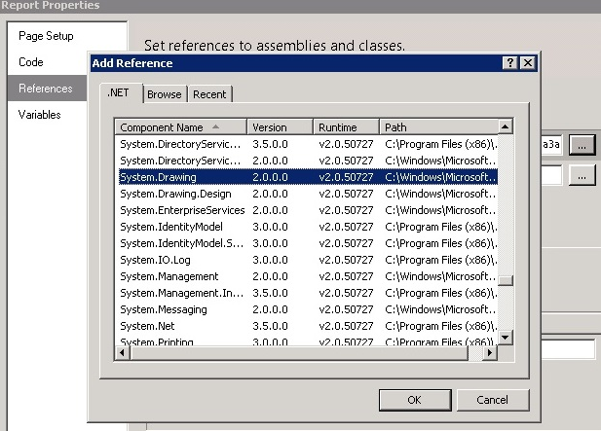

* + Then Reference barcodelib.dll from the Reporting Service bin folder.

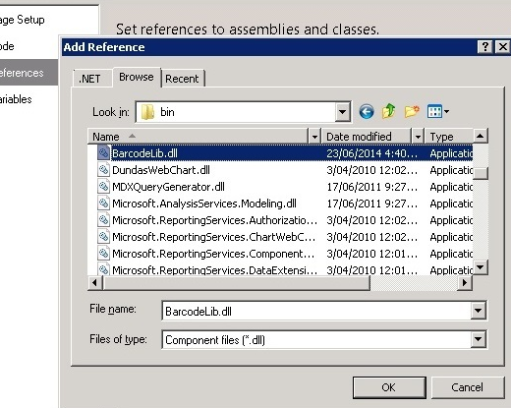

1. Add a class on the same screen (Reporting Properties: References)
   * Class Name: BarcodeLib.Barcode
   * Instance Name: bar
2. Add the following code to the “Code” Section of the Report Properties menu:

Public Function Convert(Text As String) As Byte()

Dim b As System.Drawing.Bitmap

' Dim bar As New BarcodeLib.Barcode

bar.Alignment = BarcodeLib.AlignmentPositions.LEFT

bar.IncludeLabel = False

bar.RotateFlipType = Drawing.RotateFlipType.RotateNoneFlipNone

b = bar.Encode(BarcodeLib.TYPE.CODE39Extended, Text, 400, 30)

Dim bitmapData As Byte() = Nothing

Using ms As New System.IO.MemoryStream()

b.Save(ms, System.Drawing.Imaging.ImageFormat.Bmp)

bitmapData = ms.ToArray()

End Using

Return bitmapData

End Function

* + This script can be modified by changing the height/width the: (400, 30).
  + Barcodes are printed out using the “Code 3 0f 9 Extended” font in a .bmp format. Both the font and the format can be changed. Available fonts/ formats can be found in the BarcodeLib.cs file within the source file .zip.
  + Some fonts may require that you surround the text with asterisks * before and after the text in order for bar code readers to read them. The default font does not need this with the scanner I tested it on.

1. Now that the setup is in place add the actual barcode field to the report.
   * Insert an “image”- this will be blank for now.
   * Select image properties.
     + For “image source” select: Database
     + For “Use this field” type in the expression using **Code.Convert()**
       - Ex: Code.Convert(max(fields!FieldName.value , "DatasetName"))
     + For “Use this MIME type” select: image/bmp

